**Rossmann Store Sales Prediction**

**Team Members:**

*Aishwarya Ramakrishnan*

*Alex Anthony*

*Fravak Bharucha*

*Sagar Patare*

**Abstract**

In this project, we applied machine learning techniques to a real­ world problem of predicting stores sales. This kind of prediction enables store managers to create effective staff schedules that increase productivity and motivation. We used popular open source programming language, Python. We used feature selection and model selection to improve our prediction result. In view of nature of our problem, Root Mean Square Percentage Error (RMPSE) is used to measure the prediction accuracy.

**Problem Understanding**

It is very important for retail stores to save money on their inventory and increase profit by meeting demands. Thus, it will help a lot on stores’ earnings if their sales are predictable. In our project, we chose Rossmann as our client, which is quite a big European drug store with 3000 locations. The company collected sales data for 1,115 Rossmann stores, including holiday, promotion, competitors and so on. The store manager is required to predict the 6 weeks of daily sales for these stores. We chose Machine Learning algorithms to help find the predicted result, and to find out the importance of factors which may affect the store sales. Besides it will also help the company to understand their data and relationships between sales and other factors. First of all, the scale and range of the dataset is more than important. Second, the relationship between variable and target need to be understood. Third, the type of variables should be clear for further application.

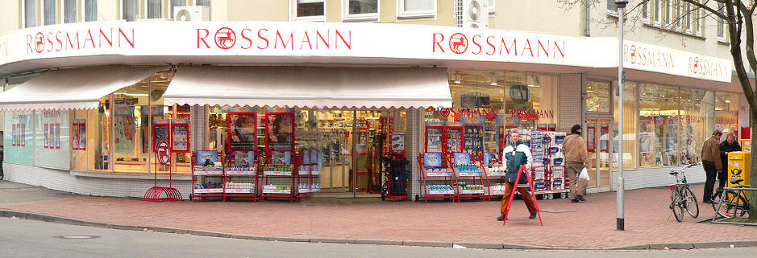

**Data Understanding**

The dataset we used in our project came from Kaggle competition. The original dataset contains two table, one is for each store’s information (competitions and promotions), while the other one is for daily sales information based on each date (feature of the day and number of customers). Columns are described in following part (Source: [Kaggle.com](https://www.kaggle.com/c/rossmann-store-sales))

**Dataset and Features**

Training data is comprised of two parts. One part is historical daily sales data of each store from 01/01/2013 to 07/31/2015. This part of data has about 1 million entries. Data included multiple features that could impact sales. Table 1 describes all the fields in this training data.

|  |  |
| --- | --- |
| **Field Name** | **Description** |
| Store | a unique Id for each store: integer number |
| DayofWeek | the date in a week: 1­7 |
| Date | in format YYYY­MM­DD |
| Sales | the turnover for any given day: integer number (This is what to be predict) |
| Customers* | the number of customers on a given day: integer number (this is not a feature. Based on the test data from Kaggle, this feature is not included in test data) |
| Open | an indicator for whether the store was open: 0 = closed, 1 = open |
| Promo | indicates whether a store is running a promo on that day: 0 = no promo, 1 = promo |
| StateHoliday | indicates a state holiday. Normally all stores, with few exceptions, are closed on state holidays. Note that all schools are closed on public holidays and weekends. a = public holiday, b = Easter holiday, c = Christmas, 0 = None |
| SchoolHoliday | indicates if the (Store, Date) was affected by the closure of public schools: 1 = school holiday, 0 = not school holiday |

Table 1: Historical sales data table features

The second part of training data is supplement store information. It has 1115 store info entries, which listed the store type, competitor and a different kind promotion info. Table 2 below describes all the field in this file.

|  |  |
| --- | --- |
| **Field Name** | **Description** |
| Store | a unique Id for each store: integer number |
| StoreType | differentiates between 4 different store models: a, b, c, d |
| Assortment | describes an assortment level: a = basic, b = extra, c = extended |
| CompetitionDistance | distance in meters to the nearest competitor store |
| CompetitionOpenSinceMonth /CompetitionOpenSinceYear | gives the approximate year and month of the time the nearest competitor was opened |
| Promo2 | Promo2 is a continuing and consecutive promotion for some stores: 0 = store is not participating, 1 = store is participating |
| Promo2SinceWeek /Promo2SinceYear | describes the year and calendar week when the store started participating in Promo2 |
| Promointerval | describes the consecutive intervals Promo2 is started, naming the months the promotion is started anew. E.g. "Feb,May,Aug,Nov" means each round starts in February, May, August, November of any given year for that store |

Table 2: Store Information data table features

**Visualization:**

Correlation Matrix

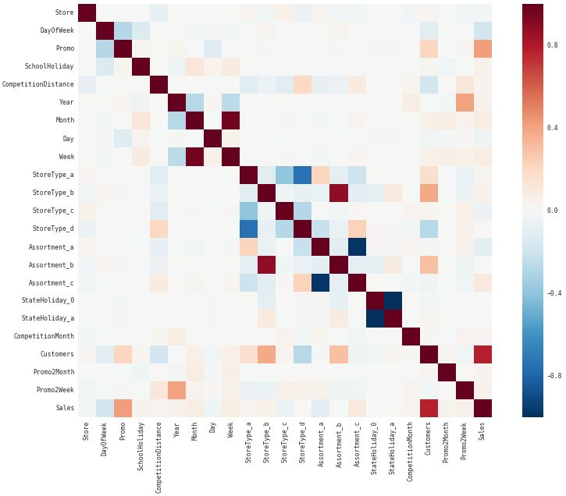

**Average sales over time(year-month):**



**Average sales & customers for each year:**



**Average customers over the time:**

Note: Customers should be correlated with the average sales over time



**Sales and number of customer across the week:**



**Visualization of sales:**



**Visualization of when the stores where open during the week:**



**Feature importance:**

Feature Importance Graph

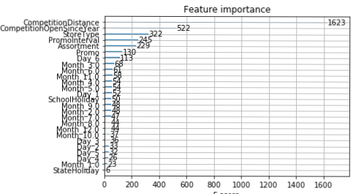

**Data Preparation**

The goal of this step is to merge train and test containing information with store table and create features for prediction.

**Feature Engineering**

1). Handling NAN in PromoInterval, Promo2SinceWeek, Promo2SinceYear - For these variables, since the data for promotion duration is not available, as there are no ongoing promotions. There are 544 such instances and replaced with zeroes. We have also coerced Promo2SinceWeek and Promo2SinceYear as object types to match the Test datatypes.

2). CompetitionOpenSinceMonth, CompetitionOpenSinceYear - have replaced the NAN's with the mode (most frequently occuring) month and year in the Store data. This is done only for visualization, and will bear no effect on the final model, as these variables are not part of the final analysis. We have also coerced CompetitionOpenSinceMonth and CompetitionOpenSinceYear as object types to match the Test datatypes.

3). CompetitionDistance - This variable has only 3 NAN's, and we have replaced this with the median of the CompetitionDistance from the Store data.

4). PromoInterval, StoreType, Assortment,StateHoliday - These are categorical variables originally, in the Store dataset. We have converted these to numeric variables, assigning numbers for each category, to enable further analysis.

5). We have dropped 172817 training examples, where the store is not open and there are no sales for the particular store.

**Model Selection:**

We tried several models in our experiment. The first model we tried is the linear regression. The prediction score is 0.14879 and we set it as the

prediction baseline. We skipped other prediction method like SVC

regression, Lasso regression and directly forwarded to ensemble learning methods, which has been proved to be the best among all other approaches in our assignment.

The basic idea behind ensemble learning is like this: given the training

data, ensemble learning uses multiple learning algorithms to find the best

representative model for the specific amount of data. So, the actual

regressor method may be different for different bulk of data. Two of the

most representative ensemble learning method are the gradient Boosting

and Extreme Gradient Boosting.

The best Kaggle competition score is 0.10021. Our current score is 0.1356.

**Evaluation**

**Model Evaluation**

We evaluated the prediction result by comparing the prediction sales to the real sales. RMSPE is the evaluation standard. The lower the score, the better the prediction.

The best prediction performance algorithm is XG Boost. When we use the similar data to predict the sales, the error rate of using XG Boost algorithm is acceptable. Therefore, we would conclude that the model is effective to predict the sales. The model is valid and reliable.

The Kaggle rank floats frequently. Our Score of submission is 0.1356.

**Deployment**

**Prediction of Sales**

* The stores can organize supply chain management and investment based on the sales prediction.
* The store needs to equip with enough products for the upcoming increasing demands. When the stores want to do short time promotion, they should prepare more supplies.
* Deployment of human resources is similar. Based on above image of average customers, stores can arrange sellers appropriately.

**Risk**

If there are some errors when collecting the data, the whole model will be affected a lot. Thus, besides using the model prediction result, the firm should do some qualitative research as well. The firm can search for the successful drug store chain sales and analyze which attributes are important to sales and how they will affect the sales.

**Future work**

We believe the sales number of a particular day is also related to the sales number before that day. Adding time series to the model can improve accuracy. We will try adding time series to the feature vector to see what we can achieve. Different machine learning algorithm such as random forest or RNN can also be interesting to explore.

**Reference**

http://scikitlearn.org/stable/modules/generated/sklearn.ensemble. GradientBoostingRegressor.html

https://www.analyticsvidhya.com/blog/2016/02/complete-guide-parameter-tuning-gradient-boosting-gbm-python/

ftp://ftp.math.ethz.ch/sfs/Manuscripts/buhlmann/handbook-cs-rev2010.pdf

https://statweb.stanford.edu/~jhf/ftp/trebst.pdf